Warm Up

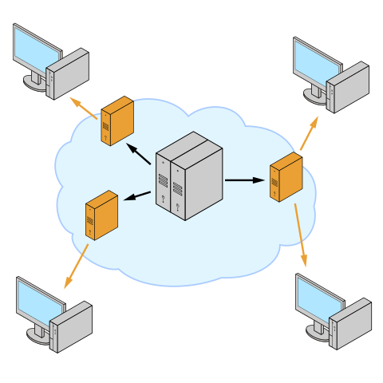

What kind of network is this?

|  |
| --- |